**2025 Envirothon Study Guide – Wildlife**

**Habitat of Kentucky**

Ecoregions - Areas where ecosystems and environmental resources are generally similar are often referred to as ecoregions.

Kentucky’s Ecoregions - Cumberland Mountains, Cumberland Plateau, Plateau Escarpment, Bluegrass, Knobs, Interior Plateau, Interior River Valley and Hills, Mississippi Alluvial Plain, Mississippi Valley Loess Plains. What characteristics define each ecoregion in Kentucky? How does the ecoregion impact wildlife? Be able to identify the region’s location on a map.

[2023_SWAP_PublicComment_AR02.pdf](https://fw.ky.gov/WAP/Documents/2023_SWAP_PublicComment_AR02.pdf) page 54

Major Watersheds in Kentucky – Be knowledgeable of the major watersheds in Kentucky. How does the watershed impact the wildlife found in that system? Be able to identify the watershed on a map.

[2023_SWAP_PublicComment_AR02.pdf](https://fw.ky.gov/WAP/Documents/2023_SWAP_PublicComment_AR02.pdf) page 55

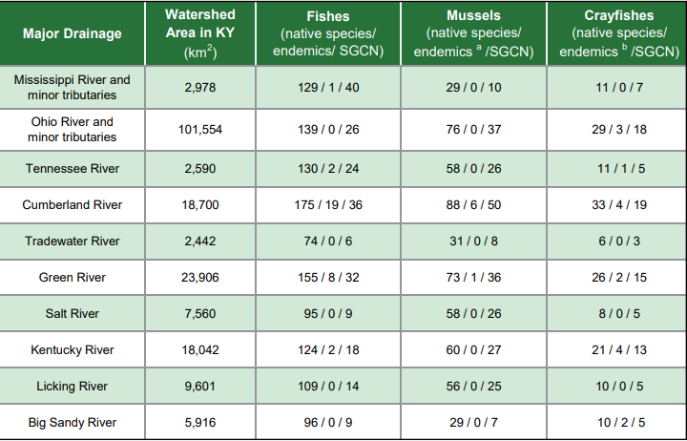

**Wildlife Diversity**

* Be able to explain these terms: Endemic, Species of Greatest Conservation Need, Extinct, Threatened, Extirpated, Endangered
* Be able to identify species of greatest conservation need. Be able to tell the species ecoregion and threats. Focus on the species found in attachment A.

**Wildlife Diseases**

* Be familiar with Chronic Wasting Disease, Hemorrhagic Disease, Avian Influenza, Avian Pox, Echinococcus multilocularis, Leptospirosis, Tularemia, Chytrid Fungus(Bsal), Black Spot, Whirling Disease.
* Ticks and tick-borne diseases.

**Invasive Species**

* Invasive species are nonnative species, often introduced by humans, either intentionally or by accident.  They compete with native wildlife for resources, alter wildlife habitat, and threaten biological diversity.  Due to the lack of predators and biological controls, they tend to spread quickly, overtaking native species and their habitats.
* Be able to identify Bighead, Silver, Grass, and Black Carp.
* Be able to identify Zebra mussels and Asian clams.
* Be able to identify *Ailanthus altissima  -*Tree-of-heaven, *Alliaria petiolata -*Garlic mustard, *Coronilla varia -*Crown vetch, *Euonymus fortunei -*Winter creeper, *Pueraria lobata –*Kudzu, *Rosa multiflora -*Multiflora rose, Lonicera maackii, L. morrowi, L. tatarica - Bush honeysuckle,
* Describe what you can do to prevent the spread of invasive species.

**Identification and Skills**

* Be able to identify Kentucky mammals by their tracks (Attachment A). Be able to identify Kentucky mammals and birds by their pelt or feathers and/or skull.
* Be able to identify Kentucky birds, mammals, and amphibians by sound. (Attachment A)
* Be able to age a white-tailed deer by their jawbone.

**Conservation & Management of Wildlife (Kentucky)**

* Be familiar with and able to explain how the Wildlife and Sport Fish Restoration Act (DJ & Pittman-Robinson Act(s) are important in funding KDFWR and wildlife conservation.
* Identify native species KDFWR has participated in or made great strides in successfully restoring in Kentucky. Examples include Bald Eagles, Peregrine Falcons, river otters, elk, white-tail deer, wild turkeys.
* Identify and describe wildlife management and reintroduction efforts utilized in the effort to restore wildlife populations and the benefits of each. Examples: “hacking”, mussel breeding efforts.
* Identify the agencies responsible for wildlife management and conservation.
* Describe the role of hunters in wildlife management and conservation.
* Describe the principles of wildlife management and recognize the difference between conservation and preservation.

Attachment A:

Wildlife Diversity Species

|  |  |  |  |  |  |
| --- | --- | --- | --- | --- | --- |
| **Amphibians** | **Reptiles** | **Birds** | **Fishes** | **Mammals** | **Mussels** |
| Streamside Salamander | Western Mudsnake | Common Raven | Redlips Darter | Virginia Big-eared Bat | Cumberland Elktoe |
| Green Salamander | Mississippi Map Turtle | Northern Bobwhite | Blackside Dace | Gray Myotis | Spectaclecase |
| Eastern Hellbender | Copperbelly Watersnake | Sharp-shinned Hawk | Relicit Darter | Little Brown Bat | Fanshell |
| Three-lined Salamander | Northern Cottonmouth | Northern Harrier | Alligator Gar | Indiana Bat | Elephantear |
| Northern Crawfish Frog | Six-lined Racerunner | Kentucky Warbler | Blacktail shiner | Tricolored Bat | Snuffbox |
| Gray Treefrog | Coal Skink | Least Bittern | Teardrop Darter | Cloudland Deer Mouse | Catspaw |

Kentucky State Wildlife Action Plan: [KY SWAP - KY Dept. Fish and Wildlife Resources](https://app.fw.ky.gov/kyswap/)

**Identification – Tracks**

|  |  |
| --- | --- |
| **Mammal Tracks** | **Bird Tracks** |
| Bobcat | Blue Heron |
| Gray Fox | Wild Turkey |
| Coyote | Canada Goose |
| Beaver | Grouse |
| Raccoon |  |

KDFWR Track Card: [For Kids - Kentucky Department of Fish & Wildlife](https://fw.ky.gov/More/Pages/For-Kids.aspx)

**Identification - Sound**

|  |  |  |
| --- | --- | --- |
| **Amphibians** | **Birds** | **Mammals** |
| Northern Cricket Frog | Eastern Screech Owl | Bobcat |
| Spring Peeper | Barred Owl | Elk |
| Eastern Gray Treefrog | Great Horned Owl | White-tailed deer |
| Barking Treefrog | Barn Owl | Black bear |
| Northern Crawfish Frog | Bob-white quail | Coyote |

KDFWR Frog and Toad Identification: [Frogs and Toads of Kentucky - Kentucky Department of Fish & Wildlife](https://fw.ky.gov/Wildlife/Pages/Frogs-and-Toads-of-Kentucky.aspx)